iyenal industries present

Making a plugin in Gen7 Engine

## With Microsoft Office default theme

So boring

1. Open Event Editor thereee in the Project Explorer window (in any project)

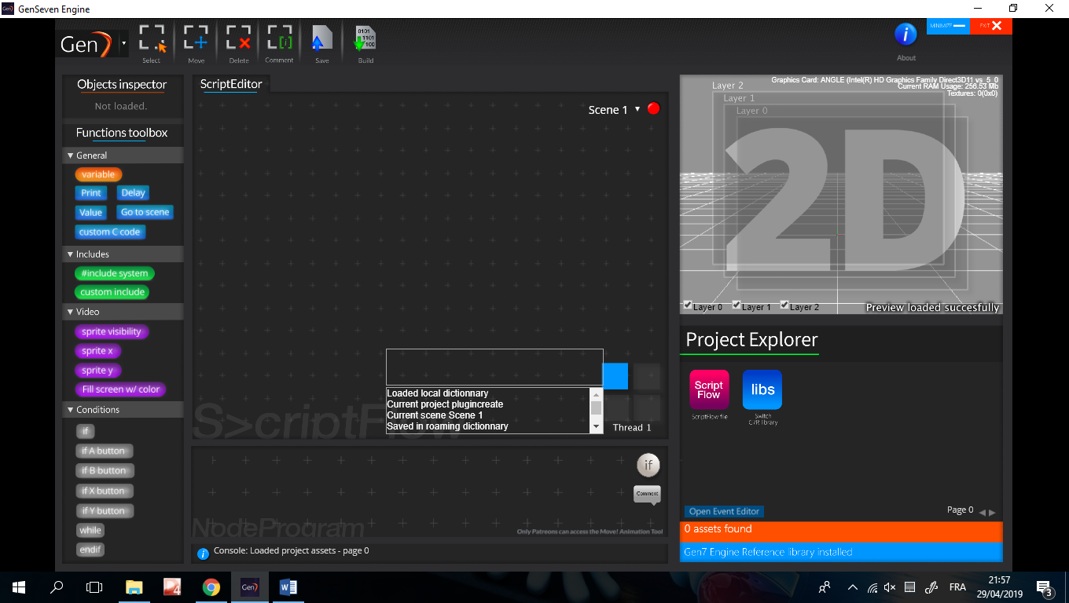

1. Welcome in the Event Extension Editor, enjoy

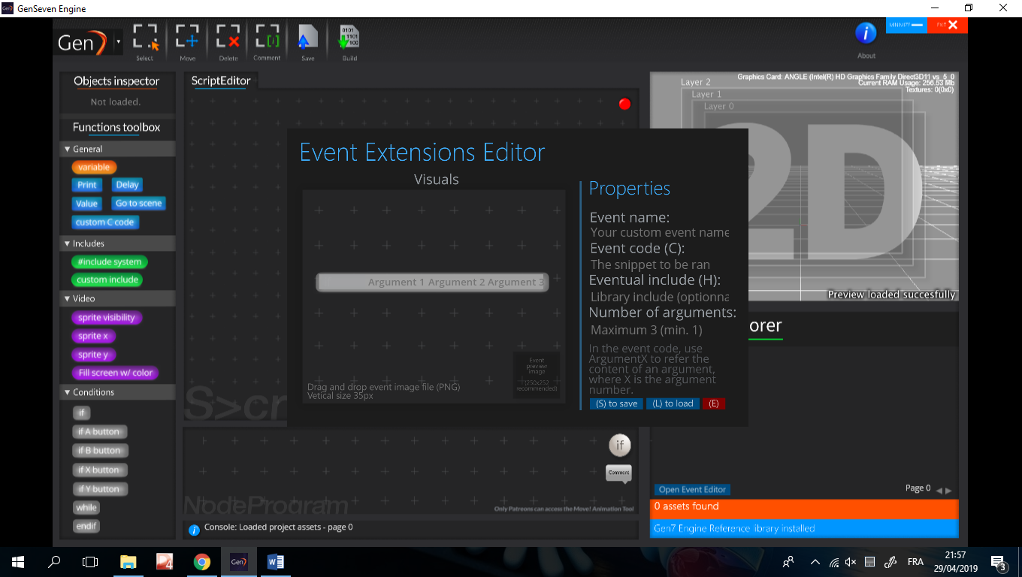

1. Fill the properties needed

For Arguments

1. Set how much arguments your event block need (min 1 but if you don’t need just don’t use it, max 3)
2. In the event code, use Argument1, Argument2 or Argument3 depending on how much arguments you set.

School Example:

print “Argument1”; with foobar as first argument will write in code print “foobar”; (it is just remplaced)

Export your event and use it

1. I think that with the time you spent reading this documentation and doing your custom event, you would like to use it. (If not then there’s a problem contact me)

TO BE CONTINUED OR CONTACT ME

Credit:

Microsoft Office 2013 for the incredible default theme

iyenal